AZURE DATA ENGINEERING
BOOTCAMP PROJECT - 5
STUDENT NAME: DASARI PRAVEEN
PROGRAM: AZURE DATA ENGINEERING

Bootcamp Project 5

- Bring the data from on premise SQL server and load the data into Lakehouse and use Lakehouse as bronze layer and get data by applying SCD types into warehouse. SCD type 1 and SCD type 2 must done in SQL using merge statements.
- Use shortcuts to bring the data from ADLS Gen2 into Lakehouse.
- Use dataflow gen 2 to clean the data which is brought in step 2.
- Load this data into warehouse.
- Schedule the pipeline to run daily once.
- Develop a Power BI report from the Lakehouse tables.
Requirements:
- Architecture
- Project documentation
- Solution in Fabric
Additional work:
- Create a new workspace and migrate the pipelines which were created in above project.

ARCHITECTURE DIAGRAM:
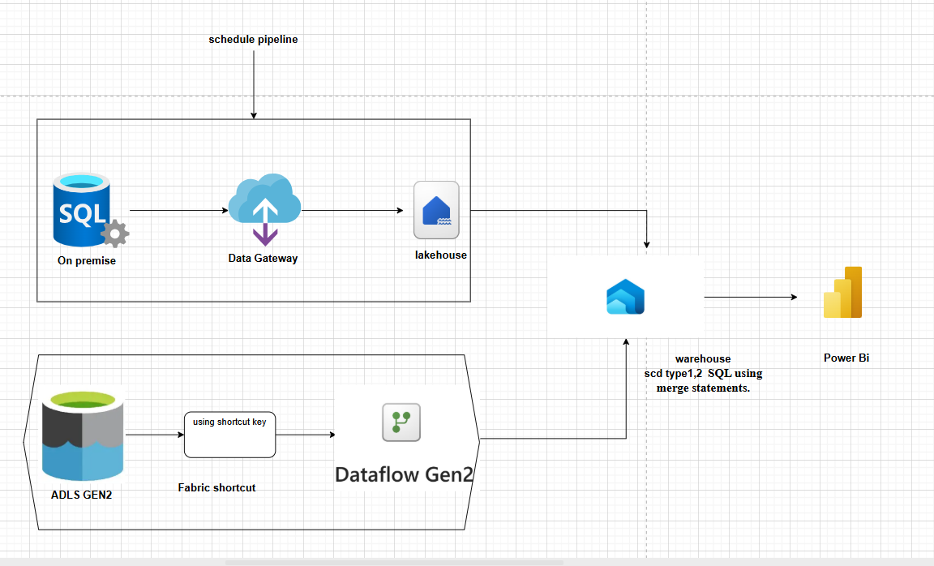

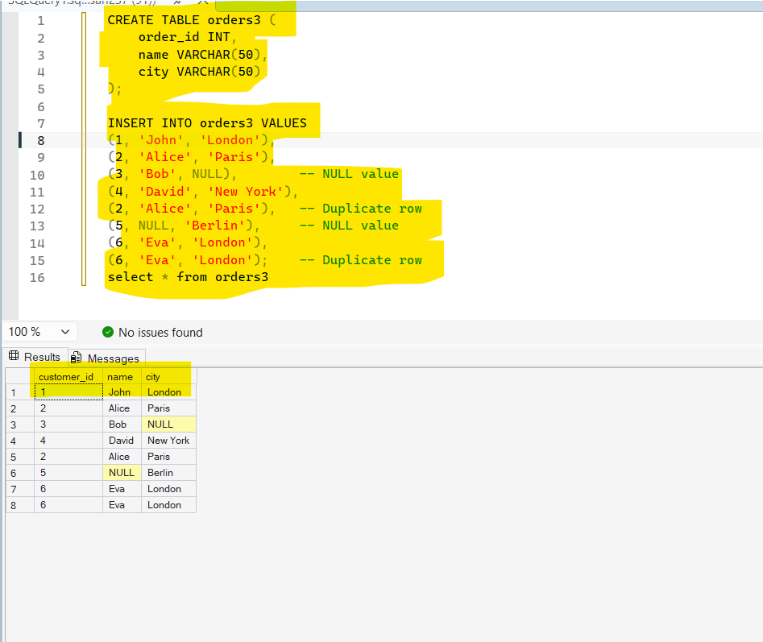
- Create a table in Sql with duplicates and null values ( this nulls and duplicates are use in tranformations)

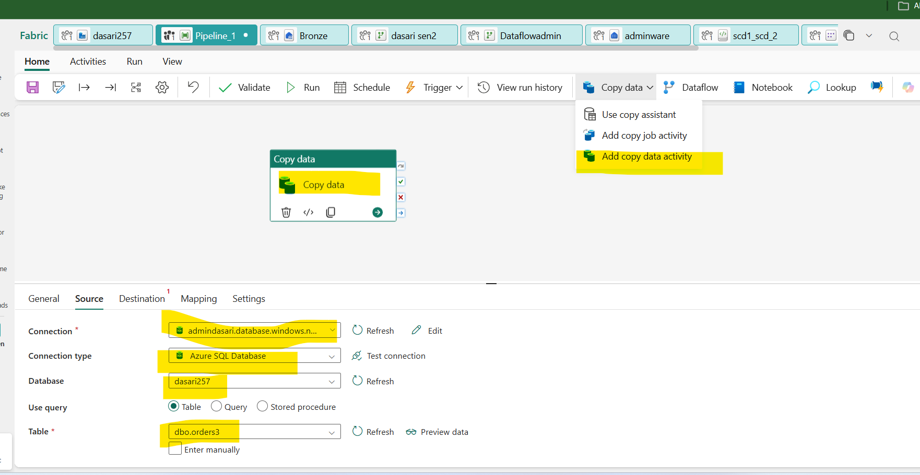
- Open fabric account and create a workspace
- In workspace add a pipeline
- In pipeline drag a copy data
- In copydata: go to source and give connection with SSMS by using the username and password and servername
- Give connection type = azure sql database
- Database= ssms database
- Table = table name ( sql table name)
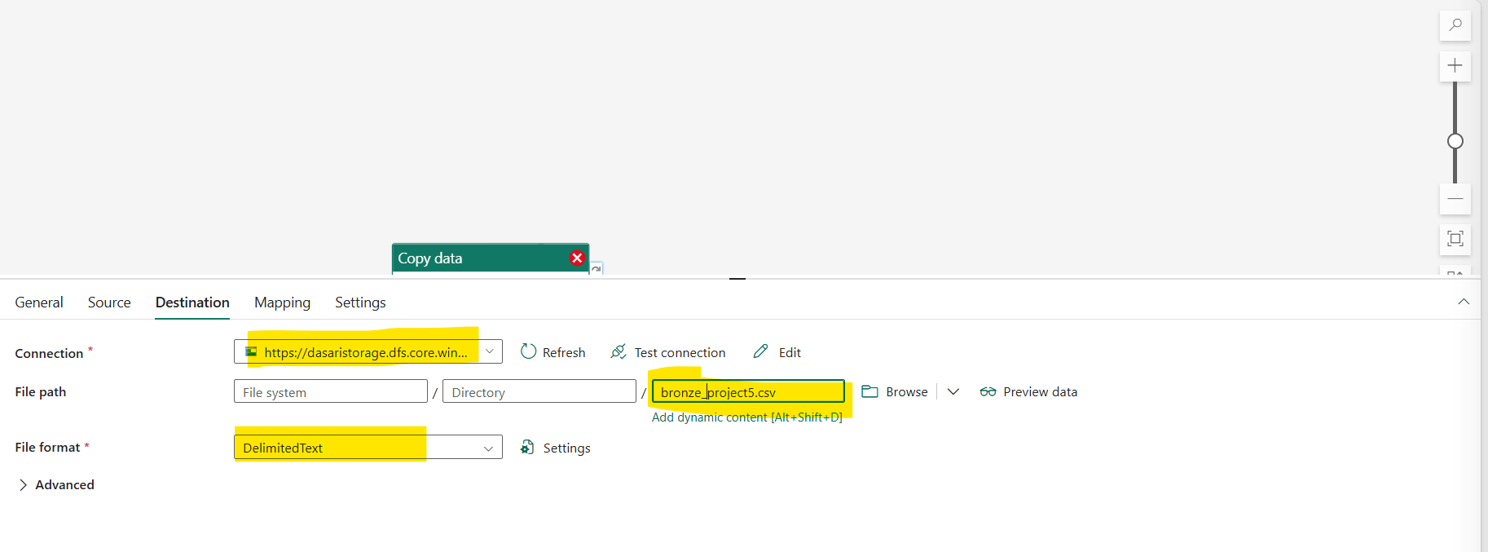
- In source : connection = adls gen2
- File path: select the container and folder by using browse

Connecting Adls to lakehouse

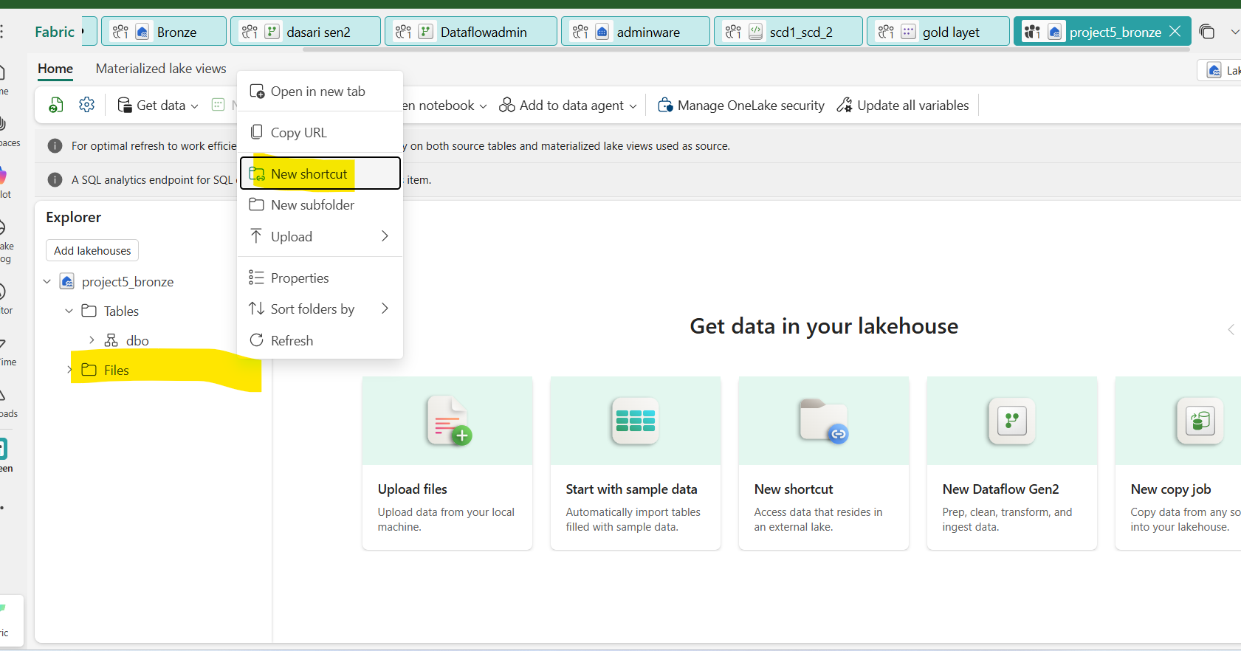
- Go to lakehouse
- right click on files
- Click on the new shortcut
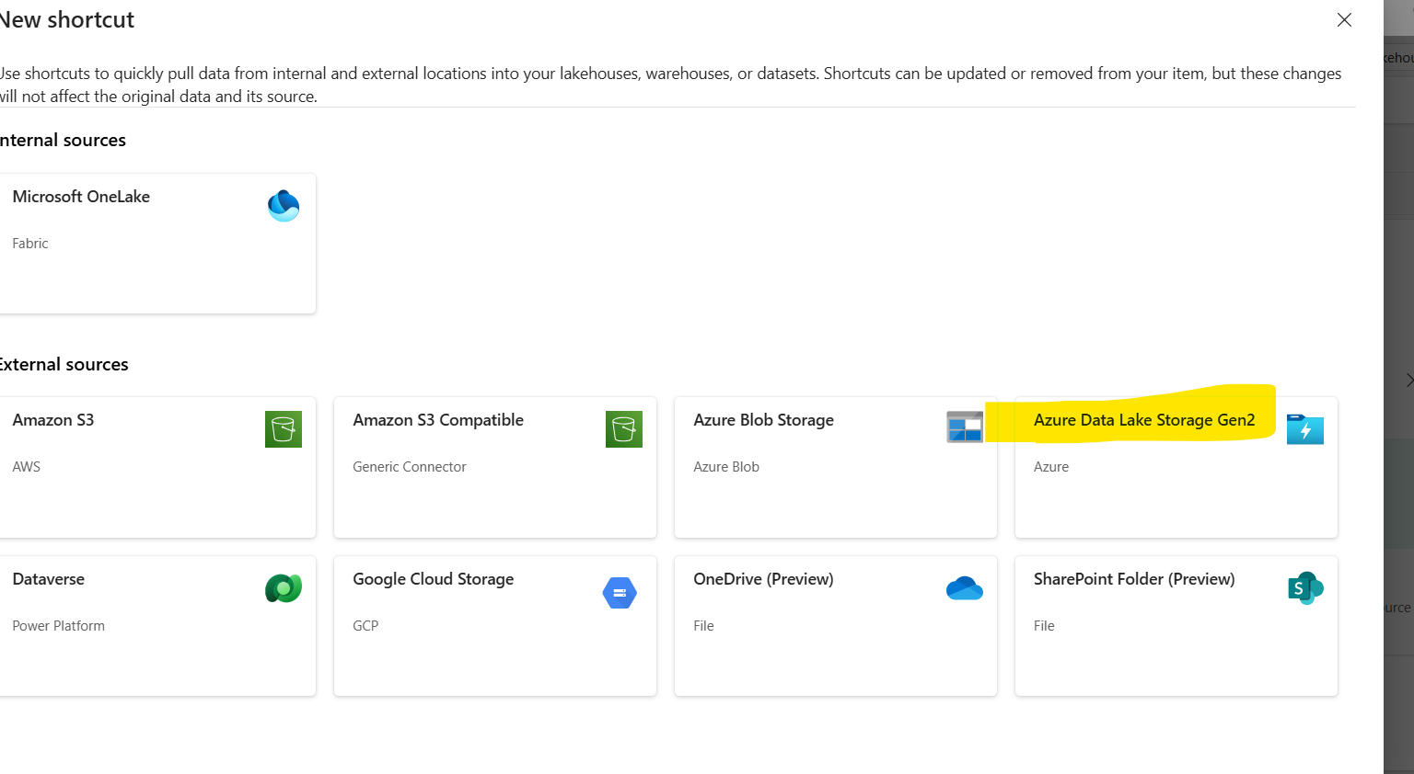
- Select ADls gen2
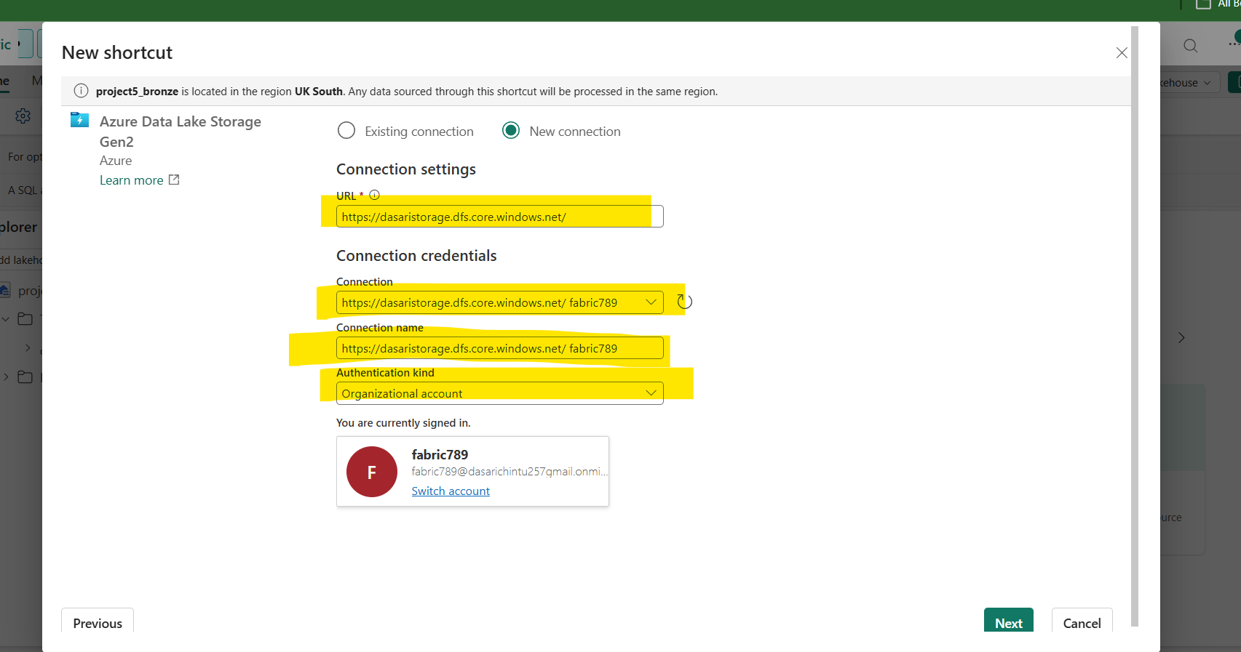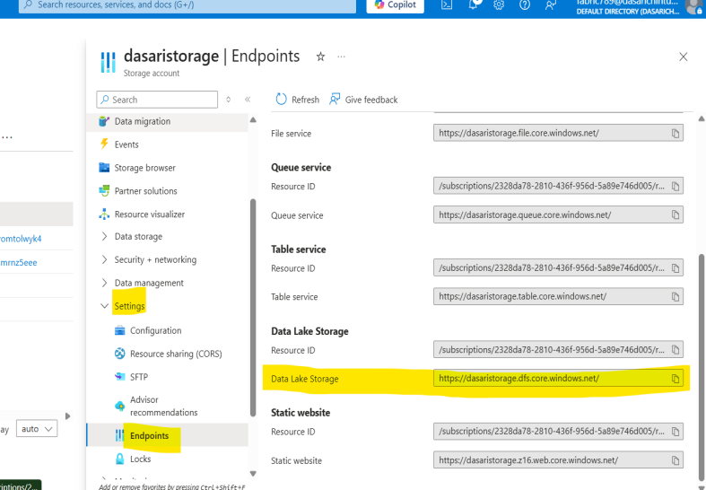

- Select the new connection
Give the URl (the URl will be availbe in the adls storage account → settings → endpoints → Datalake storage
- Give connection credentials
- (Connection and connection name will auto select)
- Give authentication kind = Organizational account

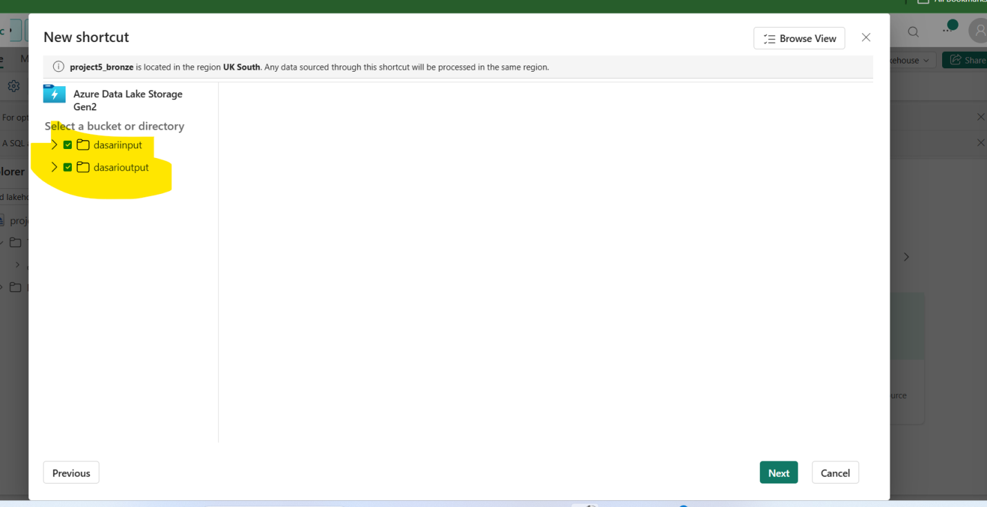
- Select the storage account containers and click on next
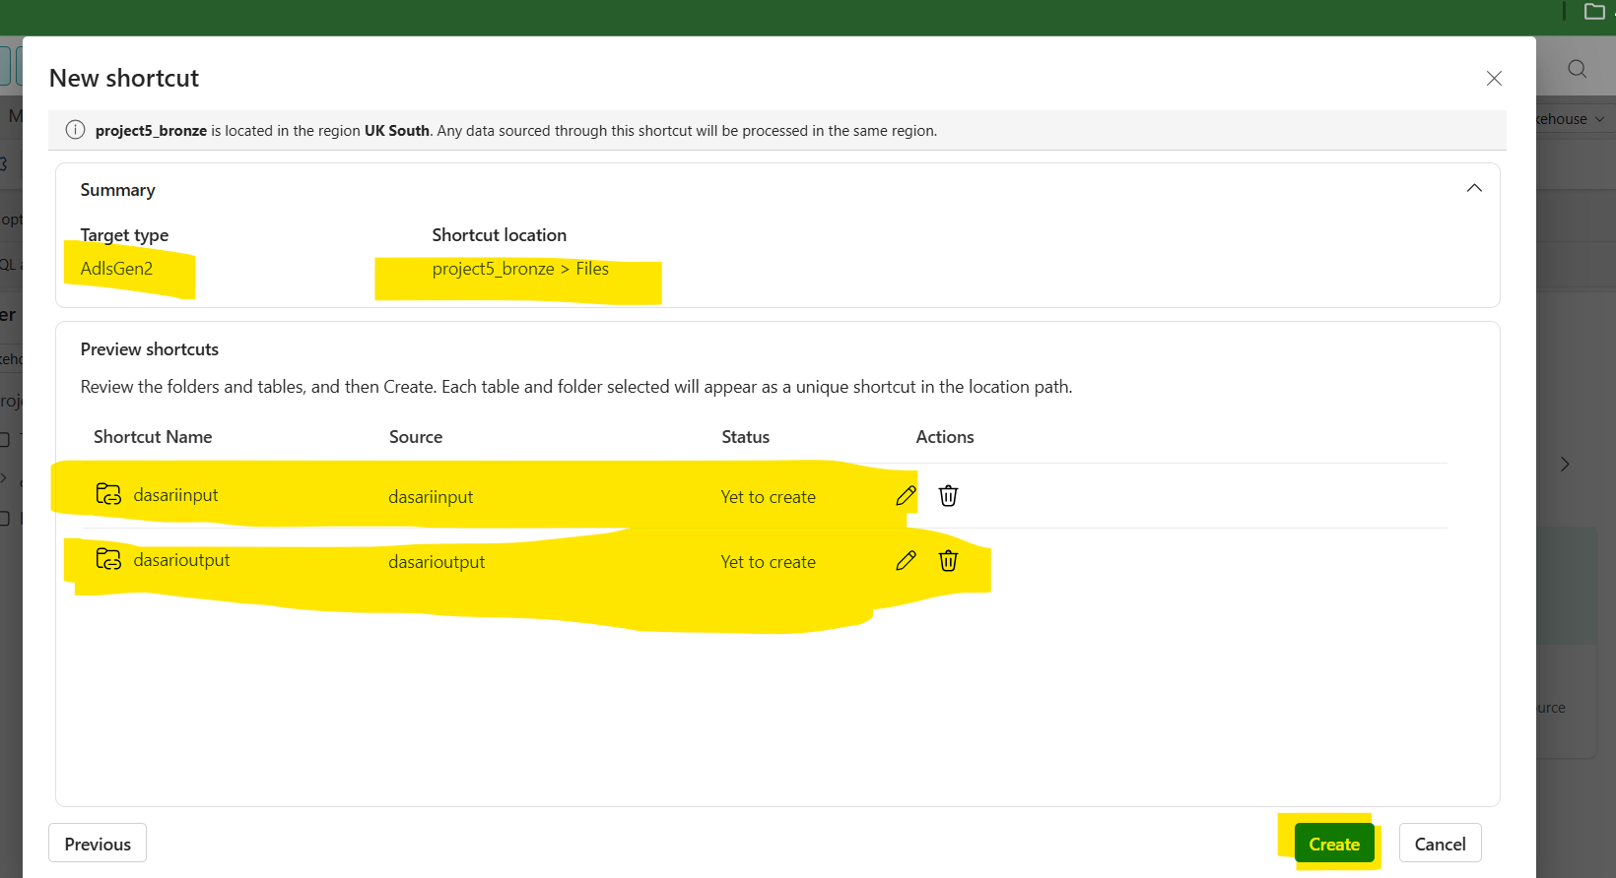
- Verify the the storage account and containers and create
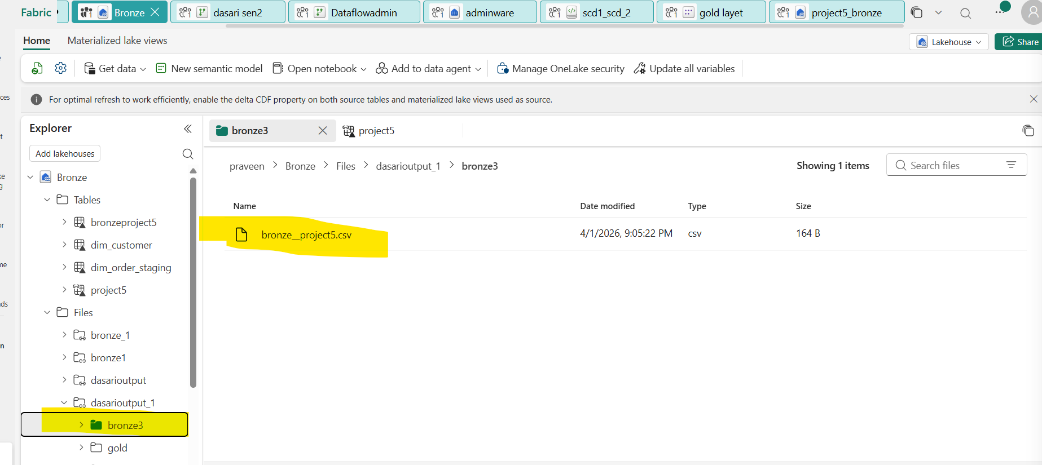
- The file will be appear in lake house

(Errors faced while connecting the adls)

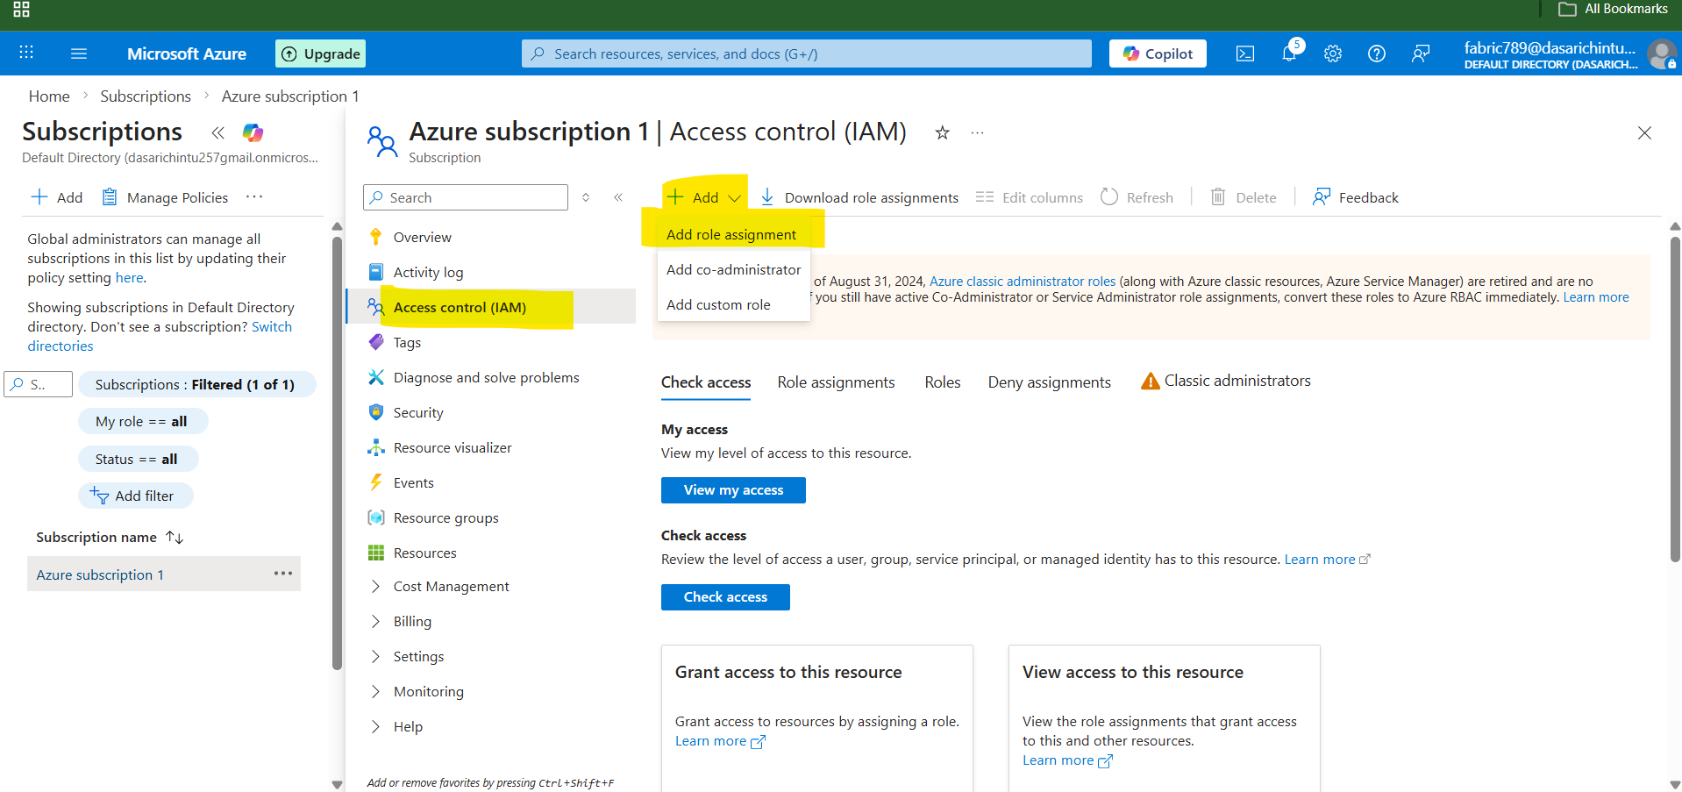
- Go to microsoft azure go to subscriptions
- Go to access control IAM and open add role assignment
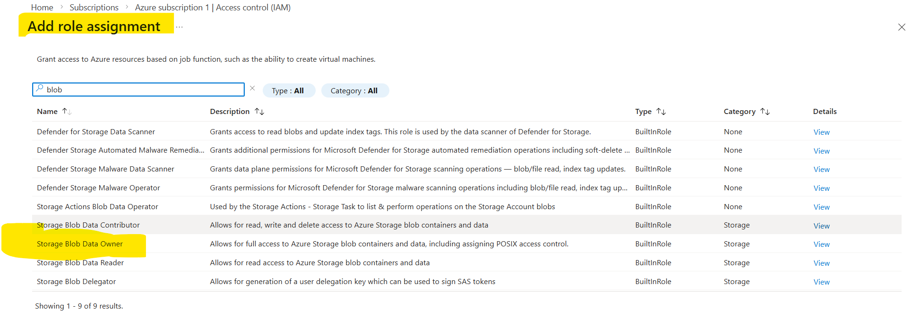
In ROLE:
- Grant the access to the storage blob data owner in job functions
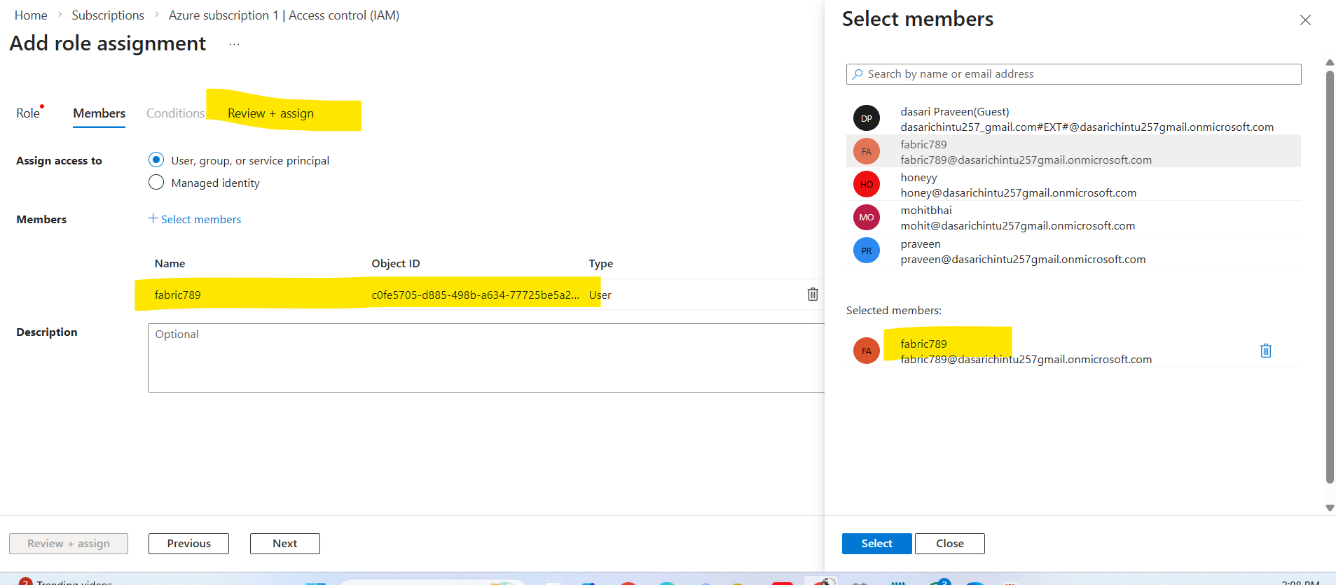
- Go to members and select the members (select the fabric account)
- Review and assign

Using dataflow gen 2 to clean the data which we brought from sql

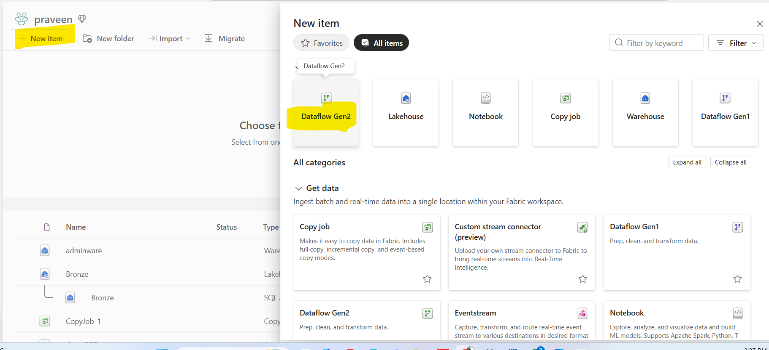
- Go to workspace and add dataflow gen2 into items

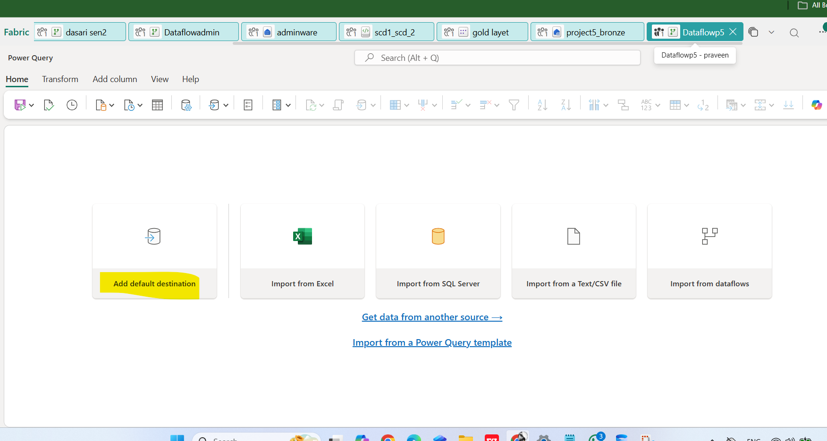
- Click on add default destination ( selecting the destination )
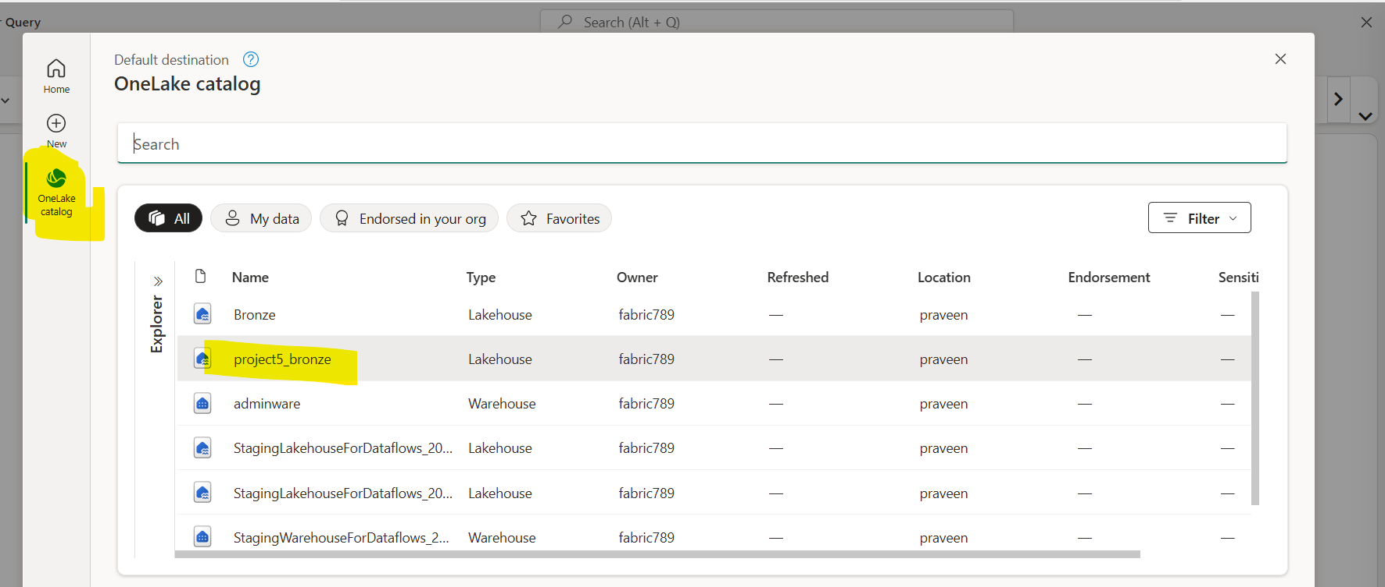
- Click on the onelake catalog
- Select the lakehouse ( we can select warehouse as well to store the cleaned data )

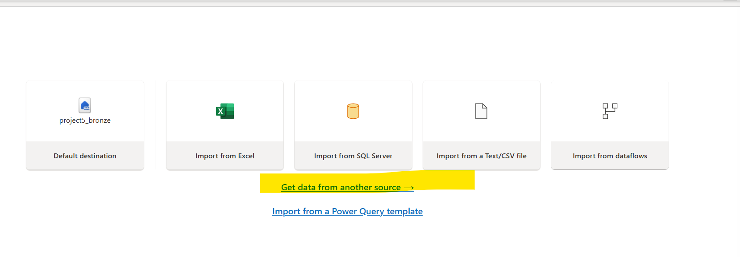
- After Selecting the destination and
Get the data from the source by selecting the option of get data from another source

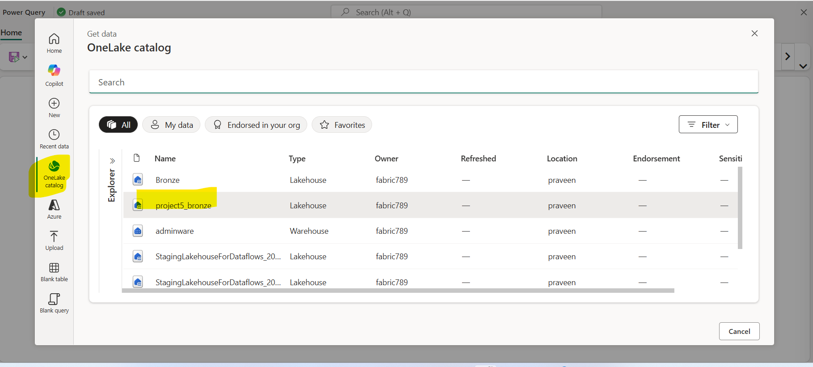

- Click on one lake catalog
- Select the lakehouse( where the file would stored)
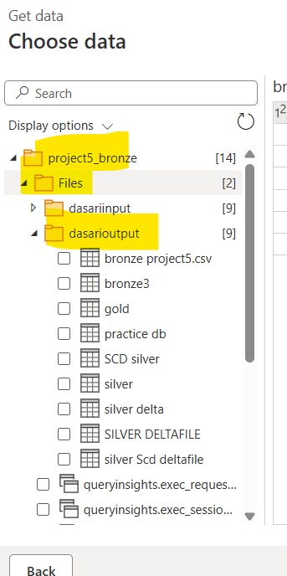

- Dropdown the lakehouse, files and container and the select the data file

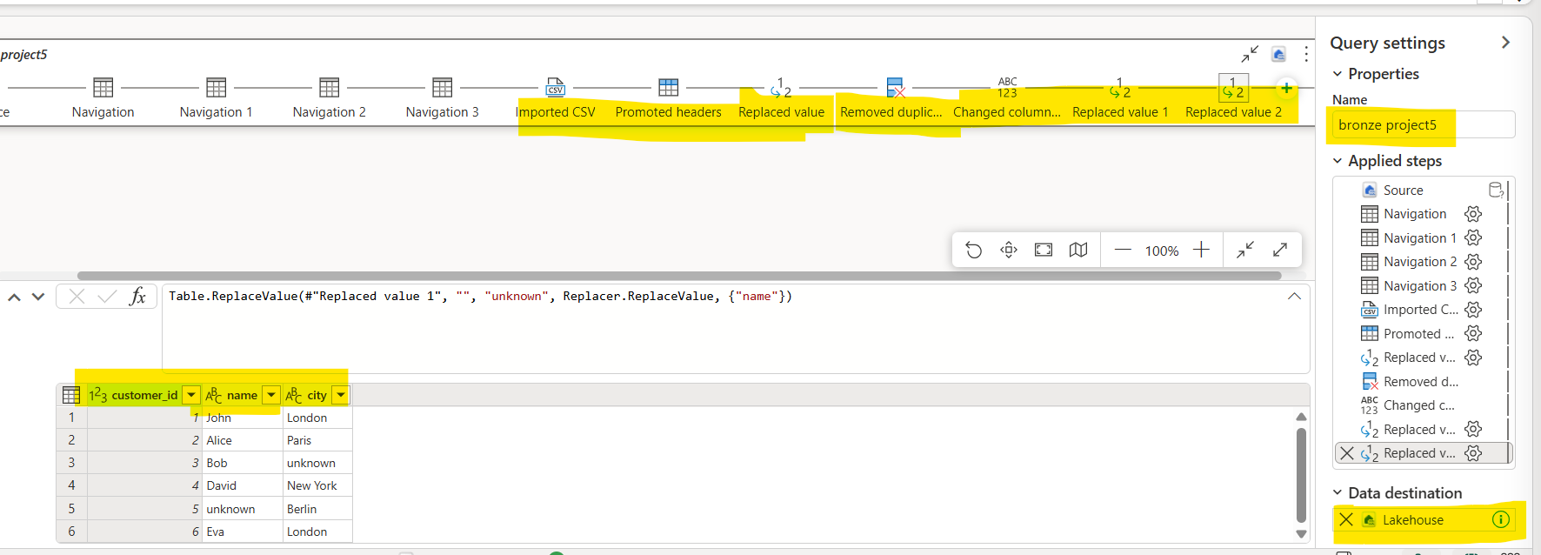
In dataflow gen2 the tranformations need to be apply
- Promoted headers = it will promote the first row as the headers
- Remove duplicates = it will remove the duplicates from the selected column
- Replace value = it will be replace the existing value to new given value
- In data flow gen2 we can change the column names, etc.….

SCD type 1 and SCD type 2 must done in SQL using merge statements.

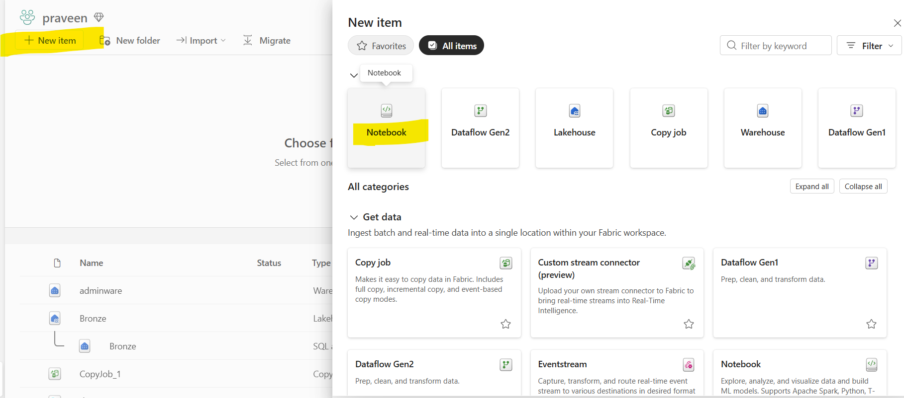
- Go to fabric workspace and search for notebook and
- open the notebook

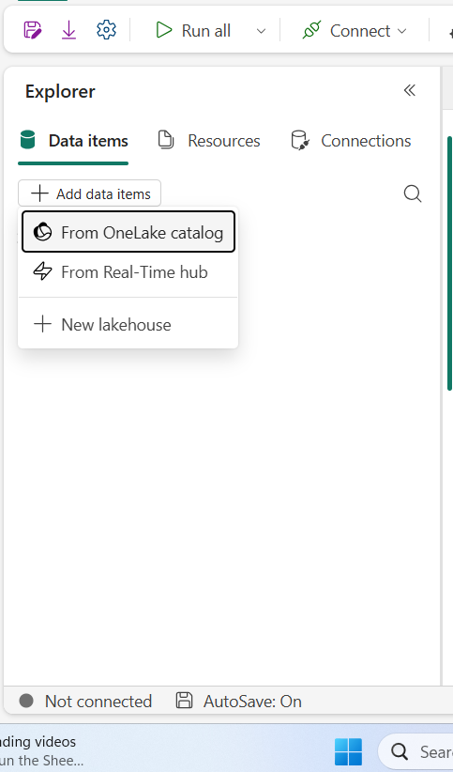
- In notebook go to add data items and
- select the onelake catalog

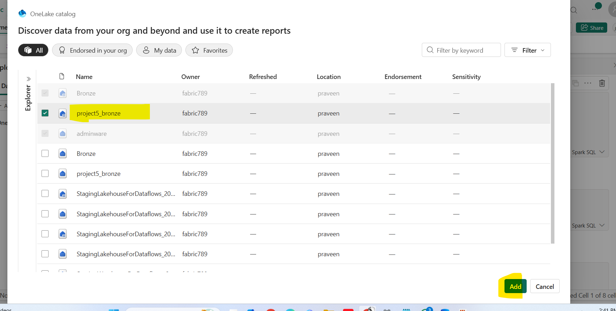
- Select the lake house ( we can select the warehouse as well instead of the lakehouse)

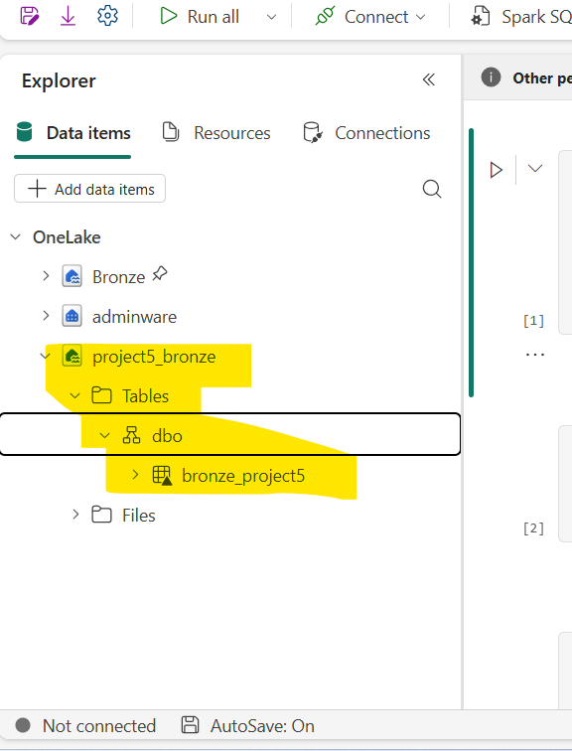

- The catalog will be appear in the note book
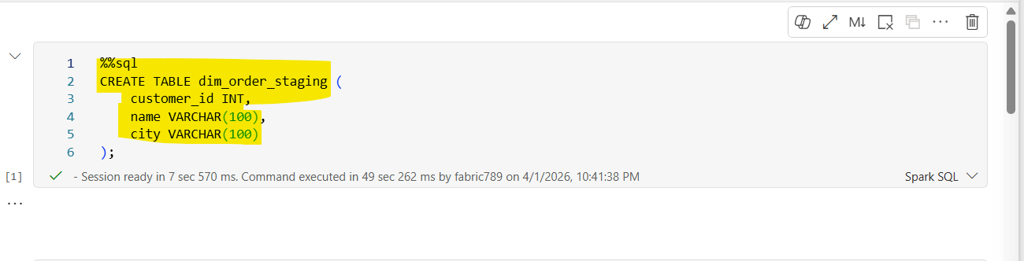
- Creating a new table name of dim_order_stagging

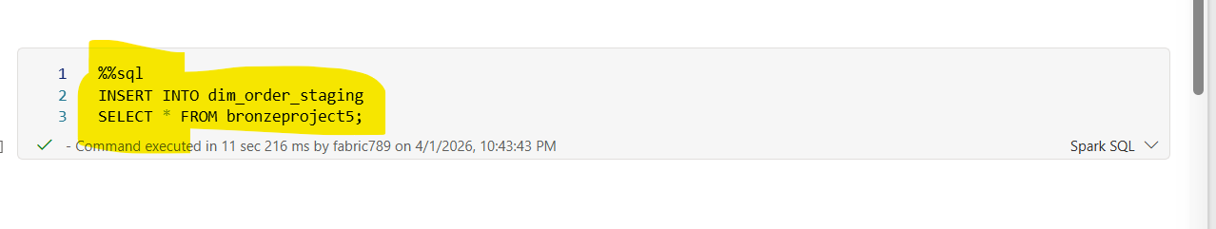
• The statement inserts all records from the source table bronzeproject5 into the target table dim_order_staging.
•
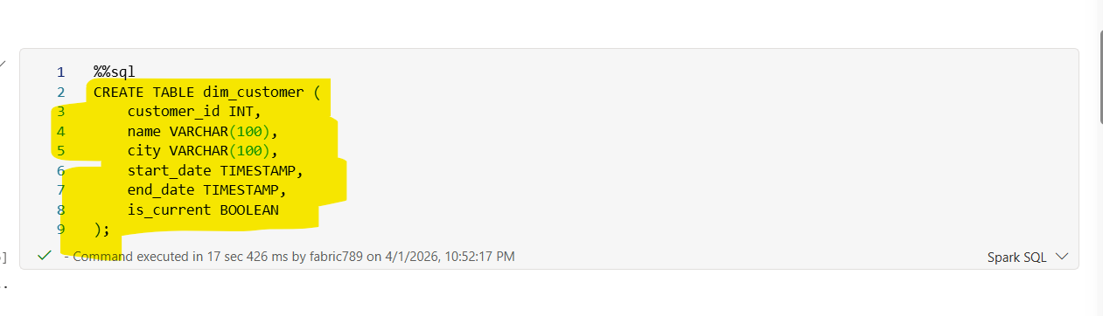
· customer_id INT
- Unique identifier for each customer.
- Used to track and link customer records.
· name VARCHAR(100)
- Stores the customer’s name.
- Variable-length string up to 100 characters.
· city VARCHAR(100)
- Stores the customer’s city or location.

· start_date TIMESTAMP
- Indicates when the record became effective.
- Marks the beginning of the record’s validity period.
· END_DATE TIMESTAMP
- Indicates when the record expired.
- Typically set to NULL or a future date for active records.
· IS_CURRENT BOOLEAN
- Flag to indicate the current active record:
- TRUE → Active/current record
- FALSE → Historical/expired record
SCD TYPE-1
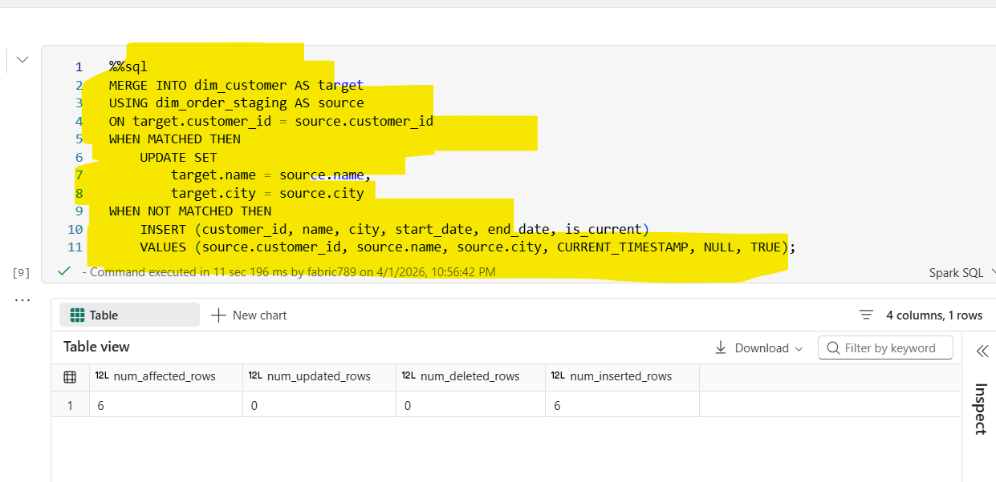
- · The MERGE statement data between:
- Target table → dim_customer
- Source table → dim_order_staging
It compares records based on:
- customer_id

WHEN MATCHED (Record Exists)
- If a matching customer_id is found in both tables:
- The existing record in dim_customer is updated
Columns updated: Name, city
Ensures latest customer details are reflected

WHEN NOT MATCHED (New Record)
- If a customer_id exists in source but not in target:
- A new record is inserted into dim_customer
- Inserted values:
  - customer_id, name, city → from source
  - start_date → current timestamp
  - end_date → NULL (active record)
  - is_current → TRUE

SCD TYPE-2
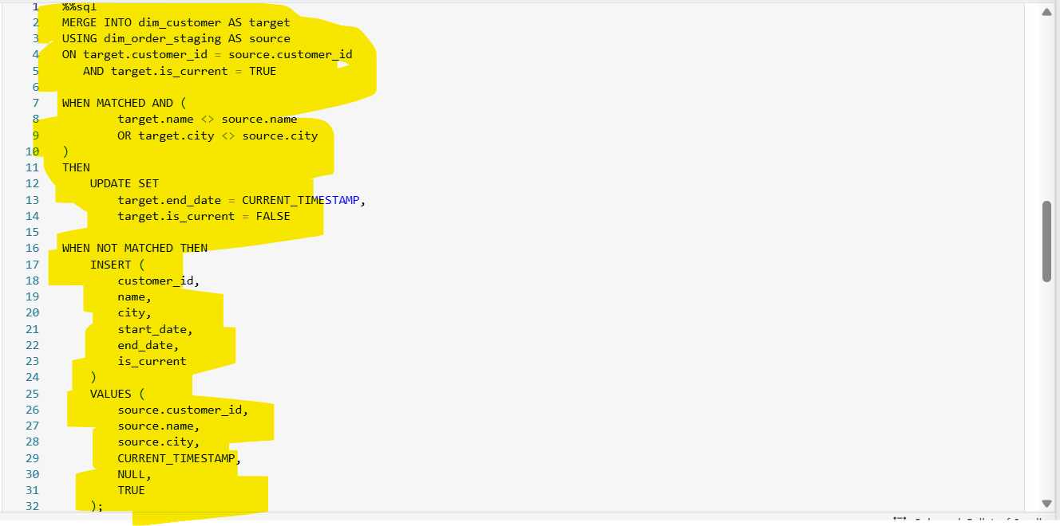
- The MERGE statement data between:
- Target table → dim_customer (dimension table)
- Source table → dim_order_staging (staging table)
- Matching condition:
- Records are matched on customer_id
- Only current active records are considered (is_current = TRUE)

- target.customer_id = source.customer_id
- AND target.is_current = TRUE
Ensures only the latest active record for each customer is evaluated.

- target.name <> source.name
- OR target.city <> source.city
If a match is found and data has changed
The existing record is expired

- end_date → set to current timestamp
- is_current → set to FALSE
Marks the old record as historical

WHEN NOT MATCHED (New or Changed Record)
If:
- No matching current record exists, or
- A record was just expired in the previous step

Then:
- A new record is inserted

Inserted values:
- Business data → from source (customer_id, name, city)
- start_date → current timestamp
- end_date → NULL (active record)
- is_current → TRUE

- Creates a new current version of the record

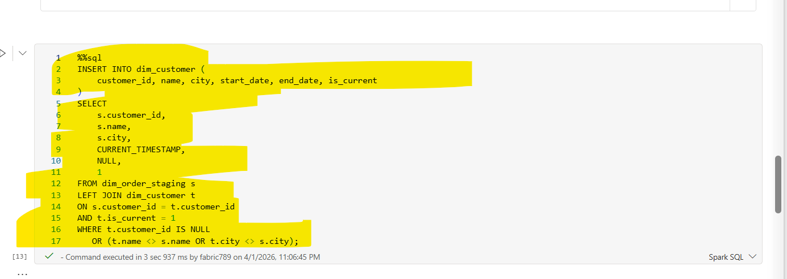
ON s.customer_id = t.customer_id
AND t.is_current = 1
· Joins staging data with only the current active records in the dimension table.
· Ensures comparison is done against the latest version of each customer.
t.customer_id IS NULL
OR (t.name <> s.name OR t.city <> s.city)
This condition selects:
New Records
- t.customer_id IS NULL
- Customer does not exist in the target table
Changed Records
- t.name <> s.name OR t.city <> s.city
- Customer exists but attribute values have changed

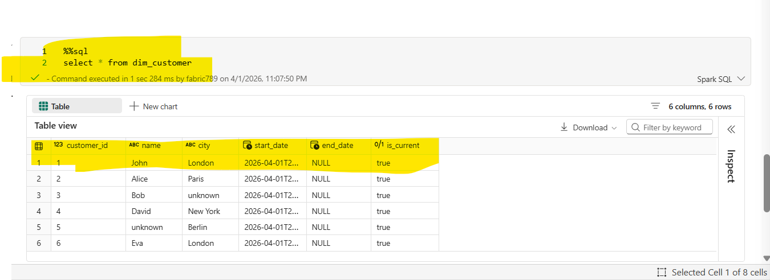
- The query retrieves all columns and all rows from the dim_customer table.

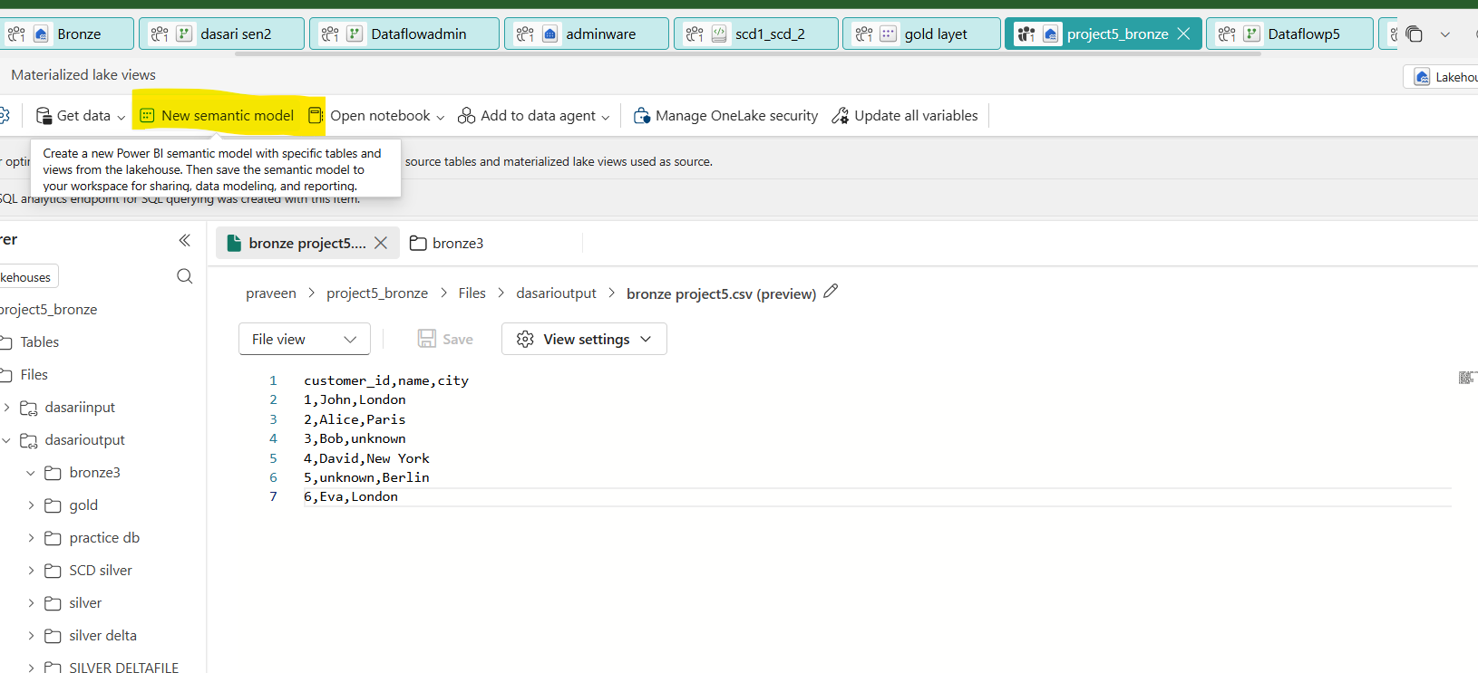
- Go to the lakehouse and open updated file and click on new semantic model

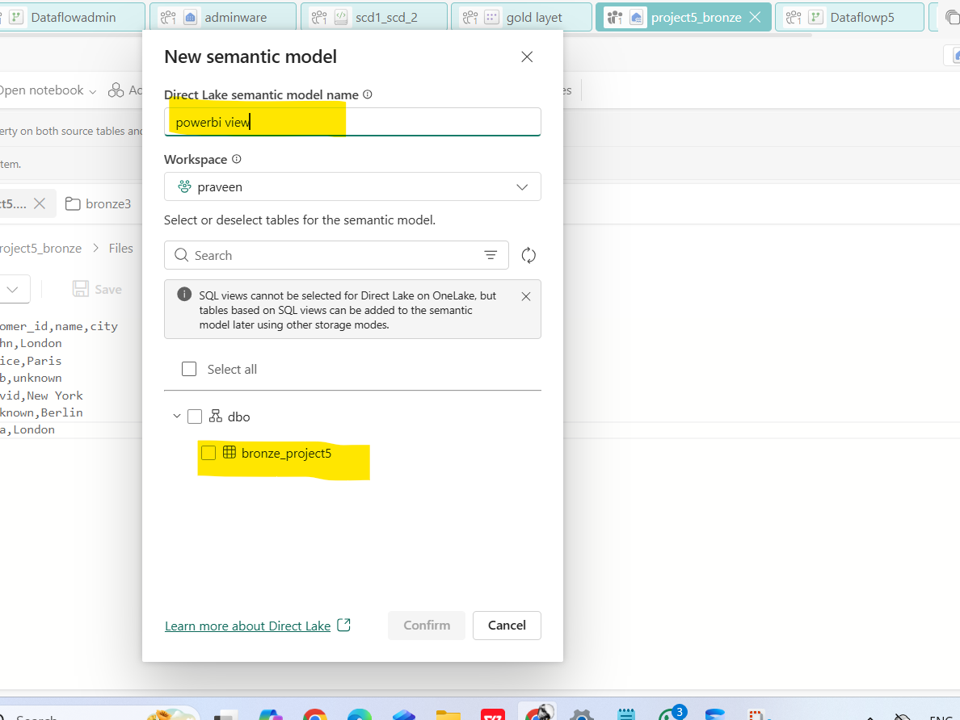
- Give the semantic model name and select the updated file
- And click on confirm

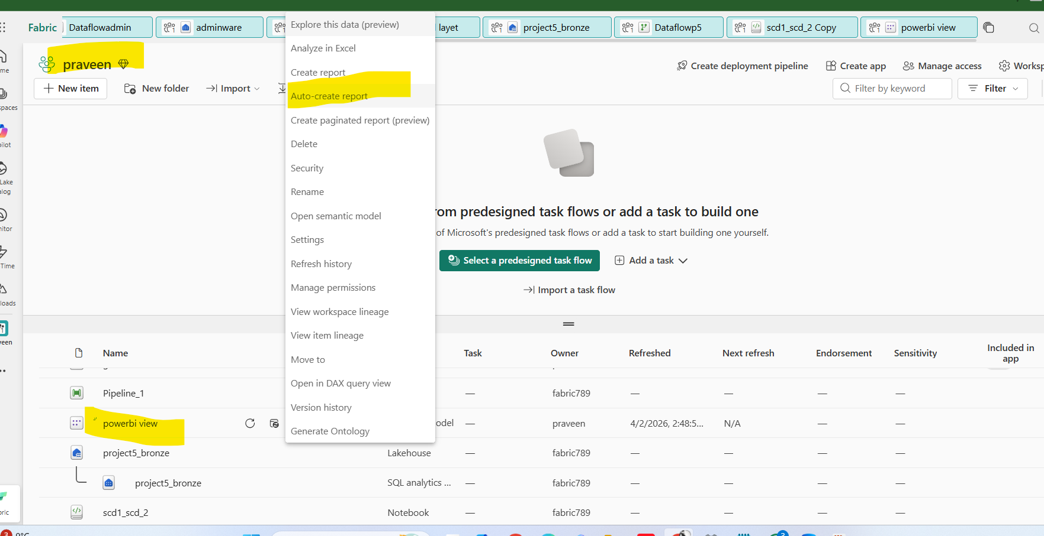
- Go to the workspace and click on three dots on selected file and choose the auto create table

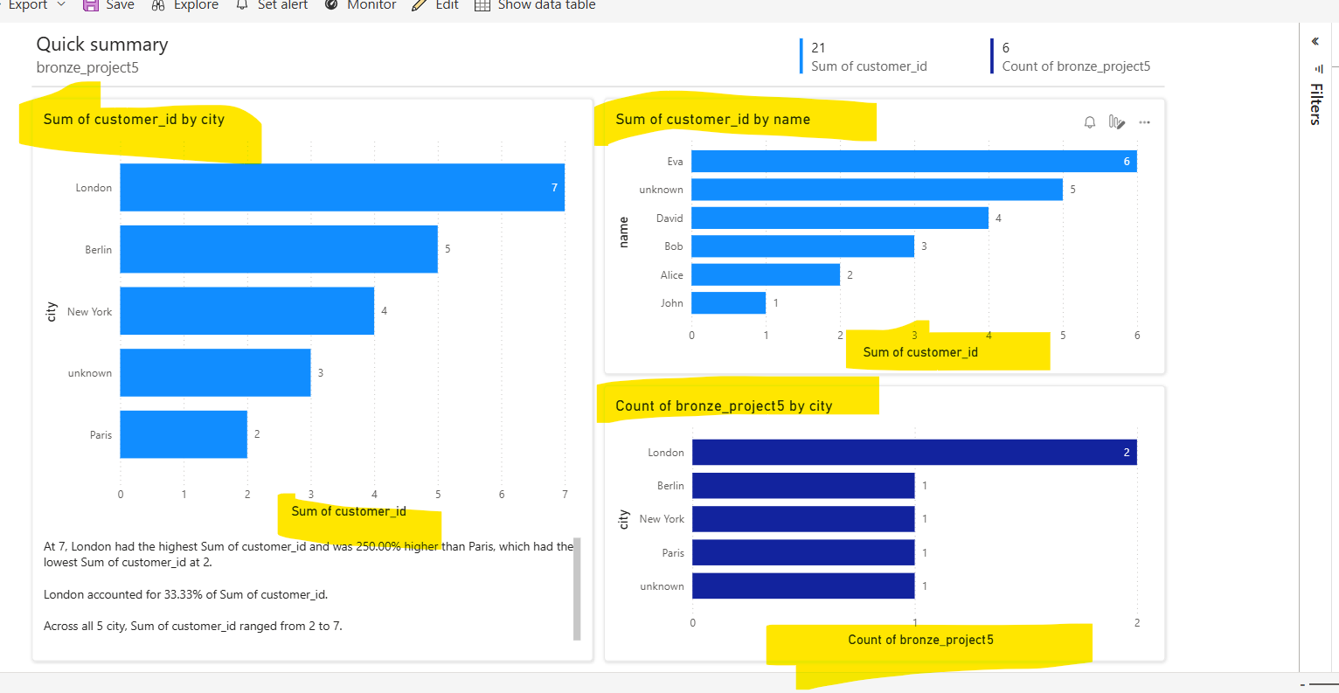

- the table will be generated in this format

Thank You

